Topic: Types of Graphs
Name _____________ Date ____________
Block ________
Part I: Bar Graph
Bar Graph: Uses bars to show and compare data
**Usually displays different categories**
Graph #1
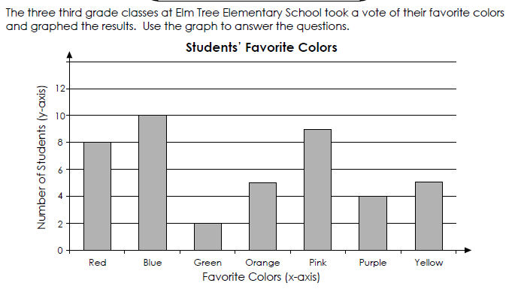
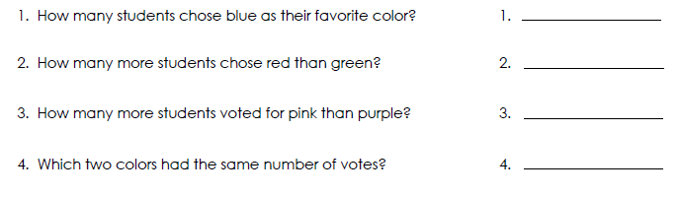

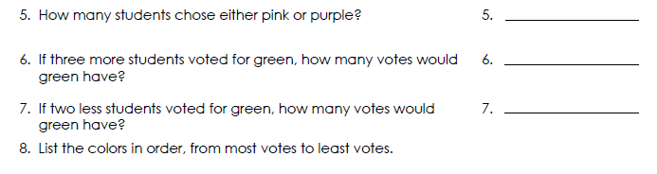

Graph #2
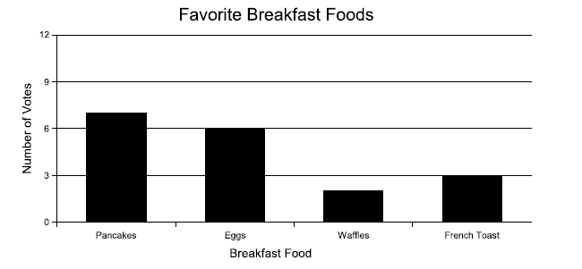
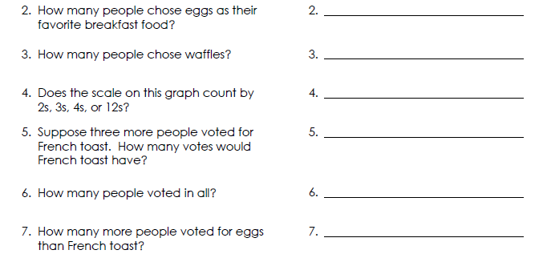

Part II: Line Graph
Line Graphs: Show how data changes over time

Graph #1
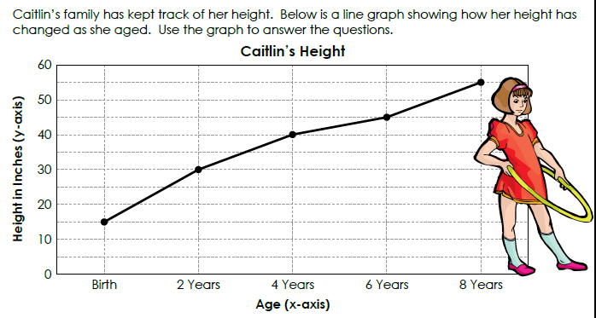
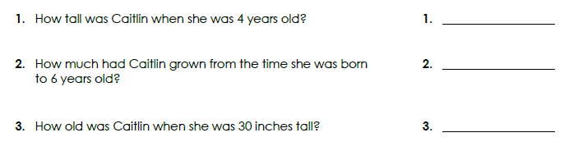
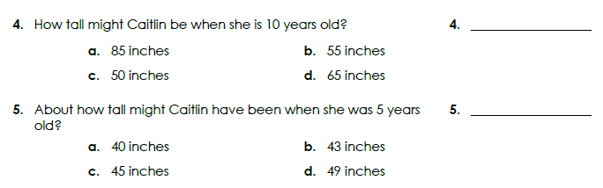
Graph #2
